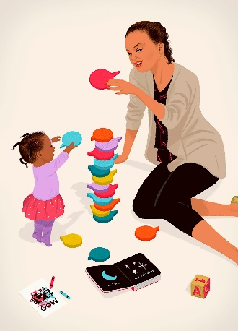
Talking to your Child
Below are some suggestions and tips for helping your child to develop their communication and language skills.

Suggested Ideas | How Adults can support
Use Commentary | Model language to your child by talking to them about what they are doing, or talking about what you are doing, this can be simple things e.g. “I’m pouring the orange juice into the small cup.” Doing this will help expose them to lots of vocabulary.
Use Gestures | Together with spoken language, gestures will capture your child’s interest and support understanding.
Repeat children’s language | To promote correct usage of vocabulary, you can repeat back what your child says, especially if they are speaking incorrectly – repeat back to them in the correct way. It also gives you a chance to expand on what they say e.g. “a butterfly” you might say, “wow, a big, bright, butterfly.”
Thinking time | Young children need time to process before responding. You might want to count to 10 slowly in your head before prompting them. This will give them some time to think of what they want to say.
Follow interests | If you talk about what your child is interested in, they are more likely to be motivated to speak.
Turn technology off | Model putting your own devices to one side. Face-to-face conversations are vital for developing speaking and listening  skills and are really rewarding
Explore photographs and tell stories | Talk about the differences and similarities between people, it could be family members or animals old and young – this exercise is great for sharing stories, which are so vital for communication development.

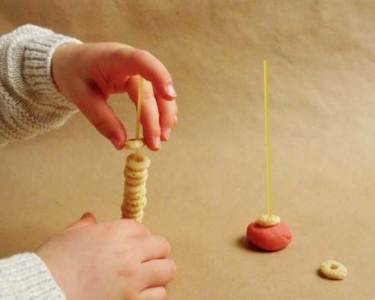
Fine Motor Skills
Before they are able to hold a pencil correctly and write, children need to develop the strength and coordination of the small muscles in their hands and fingers, this is called fine motor skill. There are lots of activities you could do with your child that will help with this, some are listed below.
Suggested Activities | How Adults can support
Play-dough/Dough disco | By manipulating playdough; rolling it, twisting it, pinching it, pounding it, and kneading it—children build strong muscles in their fingers and hands. Dough disco is a fun activity where children have a disco with their dough and do different dance moves with their hands such as splat, pinch, squeeze to the music.
Picking small things up with child friendly, chunky tweezers | You could challenge your child to pick all of the small items out of a cup using only the tweezers – you could time them and see if they can do it before it runs out. Small items could be pompoms, pasta shells, cotton wool balls, cubes, beads, buttons, pipe cleaners etc.
Small construction toys | Small construction toys such as Lego, blocks or cubes require strength and precision when used to make structures. Children have to carefully grasp, place and connect them together, this requires them to use their fine motor skills.
Cutting and sticking | Cutting practice is important, they could cut with child friendly scissors along lines or squiggles on a piece of paper. They could also rip up bits of paper, scrunch them up and glue onto another piece.
Beads on a string | Necklace, belt or pattern making placing beads onto a piece of string is great for fine motor skill development. The children have to concentrate and carefully place the string through the hole in the bead.

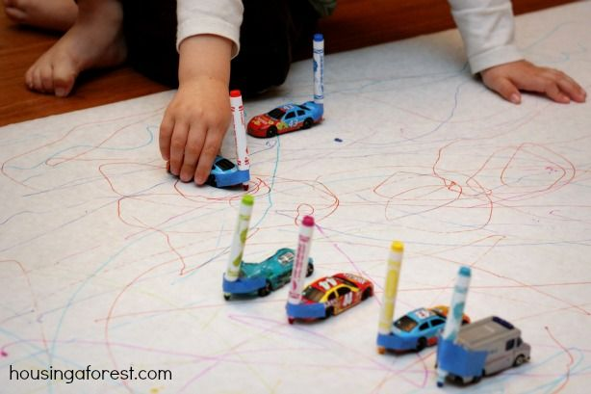
Promoting Writing
Children begin to mark make before they can write, they will eventually give their marks meaning e.g. drawing a squiggle and saying, “this is me.” The more opportunities children have to explore mark making, the better it will be for their development.
Suggested Activities | How Adults can support
Pretend Play | Provide your child with writing materials and tools when they are engaging in imaginative play. For example, if they are pretending to be a doctor, provide them with a notepad to encourage them to pretend to write a prescription. Allow daily access to materials which you have already in the home for making marks. For example, old notepads or diaries, pencils, paint, post-it notes, adult pens and chalk.
Writing for Purpose | Build in opportunities for your child to write for a specific purpose. This could include writing letters to family and friends, a shopping list for the weekly shop or a thank you card.
Sensory Writing | Before encouraging your child to use a paper and pencil to write new letters first encourage them to try forming the letters by;  - Tracing the letter in the air with their finger  -Drawing it on your back  -Using their finger to create the letter in a baking tray filled with sensory materials such as salt, flour or shaving foam.
Writing in Different environments | Place a roll of paper on the floor, you could use the back of old wrapping paper. Allow your child to lay on their stomach and draw on the paper using pencils, pens or paint. You could also stick paper underneath a table so they can mark make whilst laying on their backs. This allows them to explore new ways of mark making and also helps core muscle development.

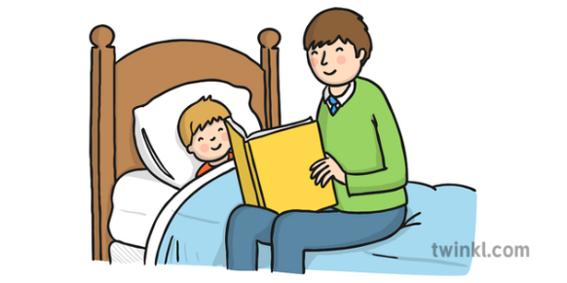
Pre Reading/Phonics
These activities will help your child to prepare for reading as they get older. Before reading can take place, they must be aware of different sounds in words. Reading daily to your child will help them greatly as they will be exposed to lots of language and be familiar with stories and the process of listening to them. It will help them develop a love for reading in these important, early stages.
Suggested Activities | How Adults can support
Listening for sounds | Set a timer for one minute and sit outside, open the window or walk around a room. What sounds can your child hear? Can they imitate any of these sounds?
Story and Rhyme Time | Try creating a cosy reading den space together using blankets and chairs. Read a daily story to your child, repeat stories again and again. See if your child can retell the story to you. When reading rhyming books, encourage your child to join in by pausing to see if they can complete the rhyme. Can they also think of a rhyming nickname for each family member?
Nursery Rhymes | Sing Nursery Rhymes with your child, this will expose them to lots of language. The rhyme and rhythm will help them to hear the sounds and syllables in words
Props and Puppets | Have props or puppets available for the different stories you read with your child. You could draw or print pictures of the characters and stick them onto lolly sticks or toy versions of the characters from the story. You could have clothes from the story e.g. mask/cape/crown. Leave these out near the book after reading it with your child, allow them to explore and act out the story themselves with the puppets/toys.
I Spy | Play 'I spy with my little eye’ with your child to help them hear the initial sound in words. To make this game easier, gather a selection of objects or toys starting with the same sound for your child to choose from. For example, a scarf, saucepan and snake.



Numbers and Counting

Suggested Activities | How Adults can support
Number Songs | Search for number songs online e.g. ‘5 current buns in a baker’s shop.’ Have a variety and allow familiarity to build before adding a new song. Sing them over and over so your child gets to know them. Sing together and use actions wherever possible.
Number Lines | Provide number labels and number lines for children to use and refer to in their play. You can use string (never leave your child alone with this) with pegs that your child can explore by moving numbers around and into correct order.
Use everyday situations | - Count in everyday situations e.g. the stairs, cars, shoes.  - Spot numbers in the environment e.g. house/bus numbers.  - Talk about birthdays - dates and months  - Use snacks as opportunities to discuss amounts and sharing e.g. half, fair, more, less
Pretend shop play | Discuss the idea of creating a shop with your child and set up the chosen shop, price objects in low amounts and use real coins. Have mark making resources available to encourage writing of words and numbers. Play with your child, allowing them to lead and swap roles.
Fingers and toes | Encourage children to match their fingers and or toes to numbers. Put hands behind backs and count together, one, two, three, four, five. Bring out hands with the correct number showing.



Exercise & Movement
It is important that children have lots of opportunities to strengthen their bones and muscles, this can be done through physical activity. A healthy diet, high in fruit and vegetables, will also benefit your child’s growth and development. Below are some activity ideas to help with your child’s physical development.

Suggested Activities | How Adults can support
Animal Moves | Discuss how different animals move to encourage your child to move in different ways such as. jumping, running, sliding, crawling, hopping.
Balance & Control | Provide ways to promote balance e.g. put a line of tape on the carpet or on a plank on the ground in the garden. You can increase the challenge by suggesting they try backwards, sideways, tiptoes etc.  - Stopping and starting games e.g. musical bumps  - Balance on one leg. Use stopwatches to see who can balance for the longest.
Dancing | Encourage children to use their imagination when moving to a variety of music genres e.g. turning, twisting, freezing, stretching, curling, landing and pivoting. There are lots of online music videos for dancing on YouTube such as ‘The Freeze Dance’ or simply dancing to their favorite songs would do.
Assault and Obstacle courses | Create these inside or out. Consider what you can use to encourage your children to move in different ways and challenge their capabilities. Allow children to create their own courses.
Welly Walks | Go for a ‘welly walk’ in the rain, allow your child to jump in puddles and explore how the ground feels different to walk on when it is wet and muddy.

